**Whitfield Aspen School : New Reports for the New Context**

Based on the idea from Elizabeth Parker-Gorman -Teacher

Written by Jason Cook Head Teacher, Anne Mason Head of School KS2 and Ali Erskine Head of School KS1

In thinking about the consequences of the majority of pupils not being in school, one of the concerns that came through from the teachers, was the relevance of the traditional school report. They noted that for reports that are sent out to parents at the end of the academic year, the teachers will not have taught the children since March. One teacher expressed that the longer she was away from her class, the more detached she was feeling. She wondered how useful and relevant it would be to write a school report which effectively would be 4 months out of date.  In fact, for some parents who have been home-schooling their own children, they have probably got a better idea of where their children are in their learning, and the areas they need to improve on, than the child’s teacher has. Also, there were concerns for the children who have not had parental supported home learning opportunities. The teachers were concerned that any information in a report would not acknowledge the potentially life changing personal challenges that these children may have experienced.

The feeling was that we could use this opportunity to create something different, which could be a small positive in an extremely challenging situation.  One teacher was keen to create a "Celebration of your child" report. She felt that being away physically from her class, had given her time to remember the funny things they have done or said.  The moments in class when they really tried hard to do something and finally succeeded!  So she created a format where she could celebrate the children showing resilience despite adversity. It was also an opportunity to acknowledge the remarkable character strengths of the children of Critical and Key-workers . In discussions with all of the teachers the feeling was that a traditional school report would not reflect what was important at a time when life has been so different and challenging for the children and their families.  We are acutely aware that many parents could be struggling with the reality of losing friends or family and would be living with the fear and reality of losing their jobs. We wanted parents and the children to have a lasting memory of the positive aspects of this time and to encourage hope for the future.

Teachers added to a list of key characteristics they felt they wanted to comment on for the children in their classes. These included the words of the values of the school (*Learning together with Aspiration, Imagination and Determination*) and the vocabulary of 5 Lenses of Engagement. **Aspiration, Determination, Imagination, Perseverance, Resilience, Kindness, Collaboration, Responsibility, Confidence, Respectfulness, Self-discipline, Consideration, Exploration**, **Realisation** **Anticipation**, **Persistence** and **Initiation.**

**May 2020**

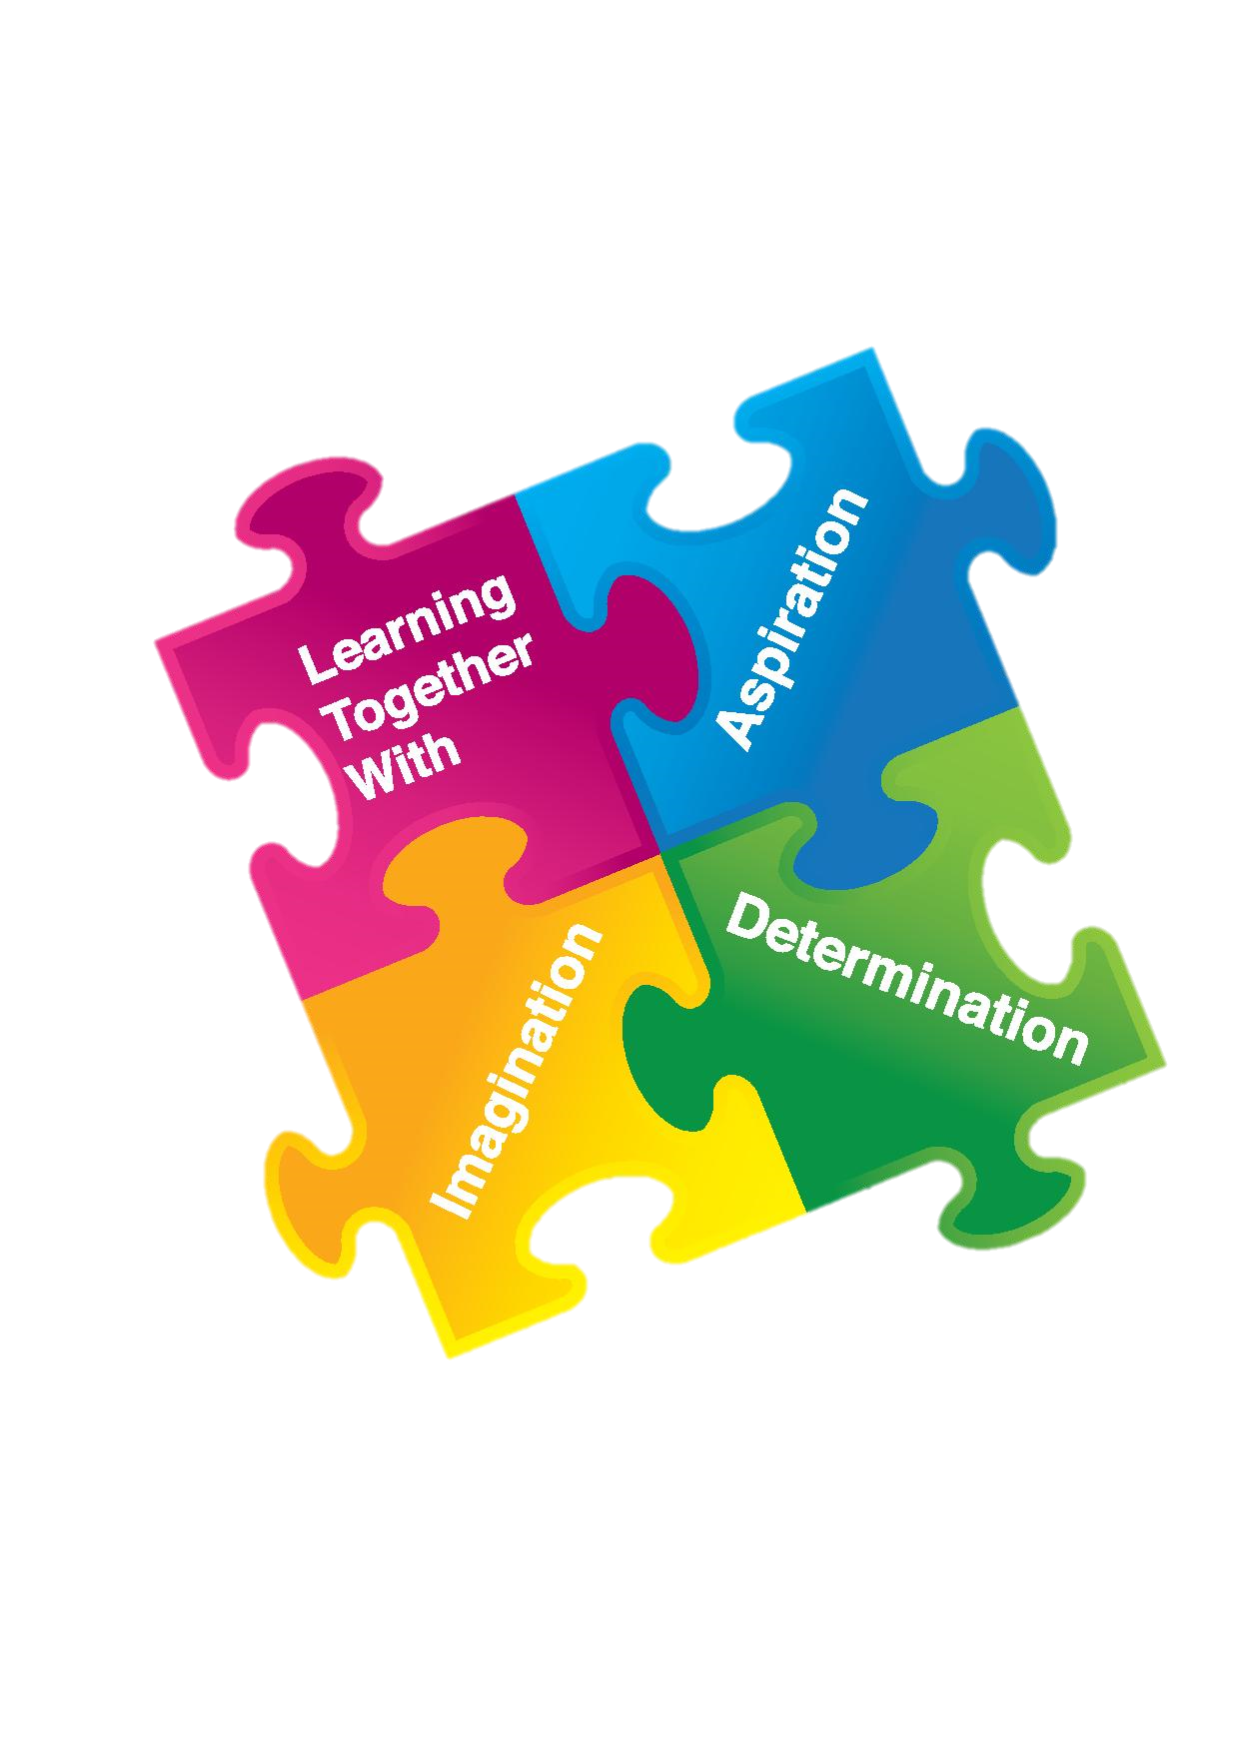A Celebration  of Your Child’s   
Achievements

**Summer 2020**

Name: Rachel

Class: 2

Teacher: Mrs P G

# Imagination

You have shown your imagination in many ways throughout the year Rachel. I have seen you have had some fabulous ideas when you work with a group. It has been exciting to see these ideas start to appear in your writing. Your home learning task to write a poem showed you have become increasingly confident in using a range of adjectives to describe how the main character was feeling. You also enthusiastically imagined how people lived in the past, in particular Florence Nightingale, and Samuel Pepys. Your ideas and thoughts in the drama and writing activities linked to this, showed me that you could really imagine what life was like.

# Self-discipline & Resilience

This year has required everyone to draw on their own inner-strengths, and Rachel, you have shown self-discipline in your engagement with the online learning tasks. It has been hard for everyone to maintain enthusiasm for learning at home , but you should be commended for continuing to try hard with this I am sure this drive to keep going, despite adversity, will be a quality which will stay with you in the future.

# Confidence & Kindness

Rachel you are a thoughtful member of the class and you have grown in confidence. I have missed seeing your smile . But, I know your new confidence and all of the other skills you have developed this year will help you when you return to school in your new class. Well done for all you have achieved both at school and at home.

# Perseverance & Determination

Rachel, you have shown perseverance all year, in the way you have worked in class, and with the class activities set whilst you have been working at home. I am always impressed in how you present your work using your beautiful joined up writing and your detailed drawings.

You have particularly shown determination when working on your reading comprehension skills. At the start of the year you found reading comprehension tasks tricky. However, you are always determined to keep trying even when you have found it hard. I can see in your book quiz scores using Accelerated Reader that you have continued to make progress. Well done for completing these regularly at home.

I know you find learning new things in maths tricky and it helps you if an adult can help you to practice new concepts. You have been determined to start learning your times tables I have really enjoyed seeing you start applying your knowledge in your home learning activities Rachel … keep practising them!

**Collaboration**

You always work well as part of a group Rachel,because you listen to other people’s ideas and I can see you becoming more confident at putting your thoughts forward too. I saw this in P.E when you worked on your group dance sequence and also in the Forest school project where your group designed a den. Your idea about making it waterproof was taken on enthusiastically by your group and was very successful as we saw in the rain! In the Christmas play, you worked hard to learn the words and signs for the songs, and at playtime you helped your friends learn the words.

*Add Photo of child or a special piece of work*



**Aspirations for Year 3**

Rachel, you can build on your ability to solve sums using the four operations (+ - x ÷) using cubes, Numicon or number lines, to develop your skills to solve word problems. You can practice these verbally to help you.

Well done, you have shown real determination to become a great reader, keep practicing your comprehension skills. Check you really understand what you are reading.

Rachel, you have shown self-discipline by continuing with your learning whilst at home. Continue to develop this skill by ensuring youpractice those skills that will enhance your learning, e.g. your times tables, and yourspellings.

**New class for Year 3**

**From September 2020 Rachel will be in xxx Class.**

**Rachel’s teacher will be Mr F**

**Term and Holiday Dates – Academic Year 2020/2021**

**AUTUMN TERM 2020**

**Date to be confirmed Staff Training Day**

Tuesday 1September – Friday 23October Term 1

**Monday 26October – Friday 30October Mid-Term Break**

Monday 2November – Friday 18December Term 2

**Monday 21 December – Friday 1 January Christmas Holiday**

**SPRING TERM 2021**

Monday 4 January – Friday 12 February Term 3

**Monday 15 February – Friday 19 February Mid-Term Break**

Monday 22 February – Thursday 1April Term 4

**Friday 2 April – Friday 16 April Easter Holiday**

**(Friday 2 April and Monday 5 April) (Bank Holiday)**

**SUMMER TERM 2021**

Monday 19 April – Friday 28 May Term 5

**Monday 3 May May Bank Holiday**

May (date to be confirmed) KS1 SATs

May (date to be confirmed) KS2 SATs

**Monday 31 May - Friday 4 June Mid-Term Break**

**(Monday 31 May) (May Bank Holiday)**

Monday 7 June – Wednesday 21 July Term 6

**Date to be confirmed Staff Training day**

**Thursday 22July – Wednesday 1September Summer Holiday**

**(Monday 30 August) (August Bank Holiday)**

**Please note: Training days are subject to change.**

**Headteacher’s Comment**

Well done Rachel, this is a fabulous report and you should feel very proud of the qualities you have shown. In particular your quiet determination to improve your reading and your engagement with the home learning tasks.

We look forward to seeing you back at school.